WORKBOOK_CREATOR user guide
For this program to work the directory should contain an img folder with a logo.ico file, a configuration file titled config.ini, an optional lot.csv and the executable WORKBOOK_CREATOR.EXE file itself. Launching the application displays the graphical user interface below:
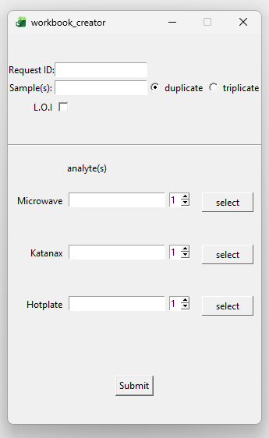
Figure 1: graphical user interface.
You are presented with an interface to input the request id, samples, a check box to apply a L.O.I correction for the analysis and a set of radio buttons to set the samples as duplicate or triplicate. After filling out the information about the request, you then input the metals analyzed and their respective digestion method. I’ve attached a sample request report to walkthrough building a workbook.
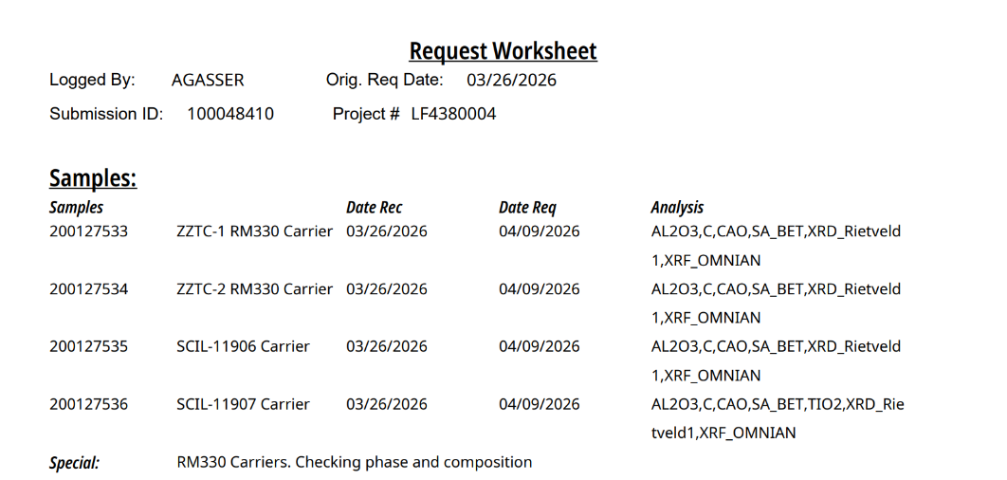
Figure 2: sample request worksheet.
Note that this sample request contains Al2O3, CaO for all 4 samples but only sample 200127536 contains TiO2. To build this sheet a separate digestion needs to be created to capture TiO2. Samples can be inputted as a comma or white space separated list; I’ve also included a shortcut if all the samples in the analysis are sequential. shortcut=leading_sample_id(n), so in our case: 200127533(4) = 200127533, 200127534, 200127535, 200127536.
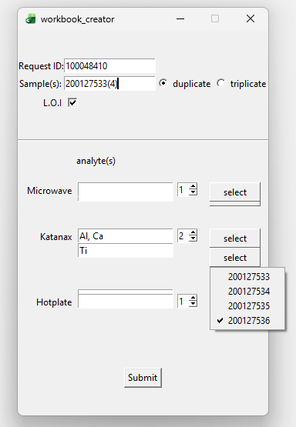
Figure 3: selecting Ti analysis for sample 200127536.
Note the separate Ti Katanax digestion to capture Ti for sample 200127536, all of the other samples are preselected for the Al, Ca Katanax digestion. Once all the pertinent info is put into the application click on the submit button to create master_woorkbook.xlsx. You are then presented with a workbook with a digestion page and a tab for each of the samples.
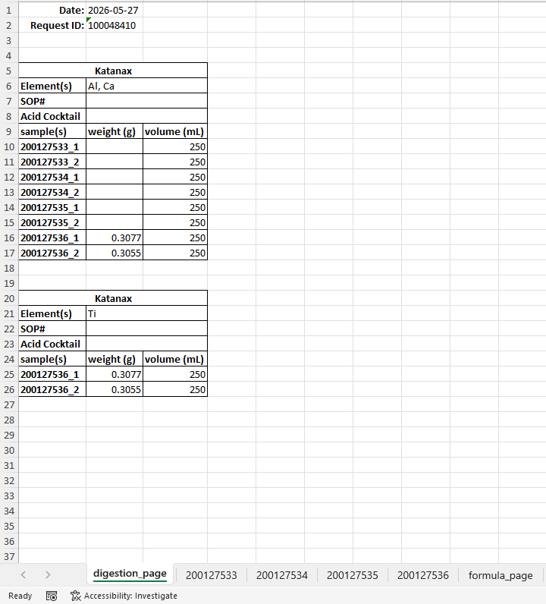
Figure 4: digestion page.
Note that the 200127536 duplicates from each digestion contain the same sample weight since they are the same solution but separated to capture the Ti analysis that is not present from the other samples.
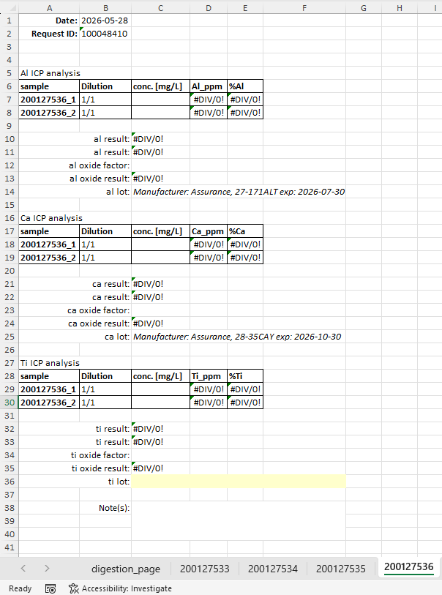
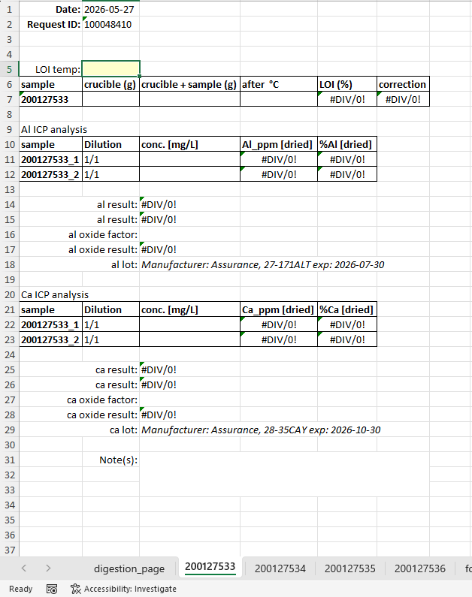

Figure 5: sample 200127533 displaying Al and Ca analysis.
Figure 6: sample 200127536 displaying Al, Ca and Ti analysis.
The software will pull the correct lot data from the lot.csv file if the lot exists and is not expired. Note the yellow unfilled ti lot box implies that either the lot.csv does not contain a ti entry or that is expired.
Analysis types:
Opening the configuration file, you can control the analytes that require titration analysis or any other analysis type.
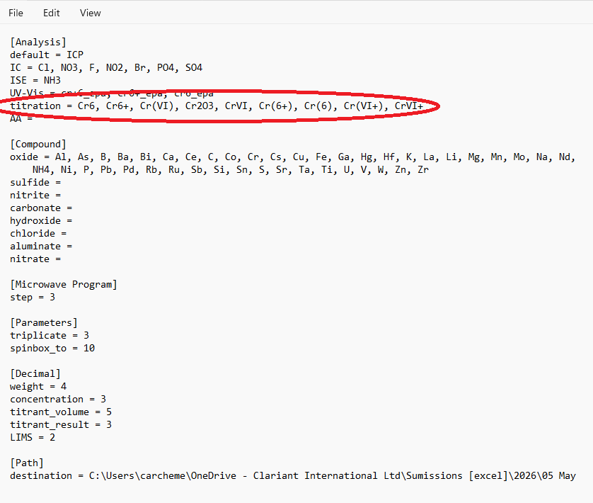
Figure 7: analytes tied to titration analysis.
Cr(III) analyst is a special type of titration analysis that takes the difference of Cr2O3 and Cr(VI) titration analysis. Let’s walk through how to set that up in the program.
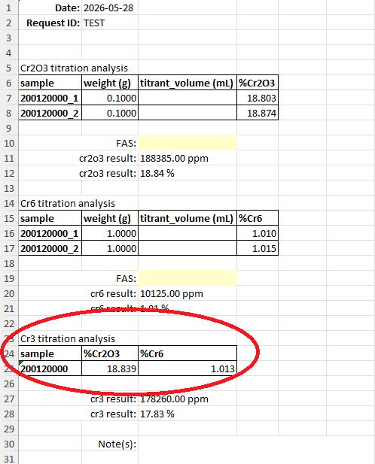
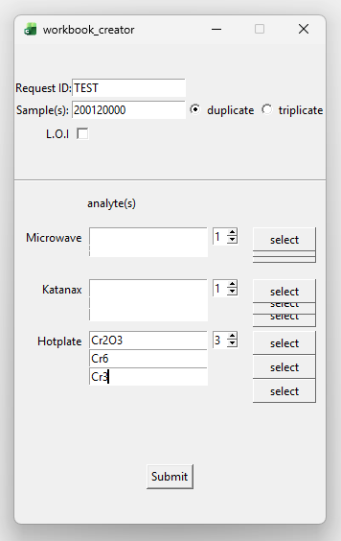
Figure 9: Cr(III) analysis.
Figure 8: Cr(III) titration analysis setup.
Any analytes that are not define in the Anlysis section defaults to ICP analysis. Note that this section of the configuration is dynamic meaning that if an instrument were to be instroduced in the lab we can capture this in our analysis. For example we can add HPLC anlysis for Cs.
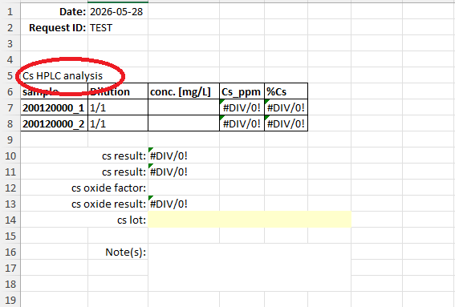
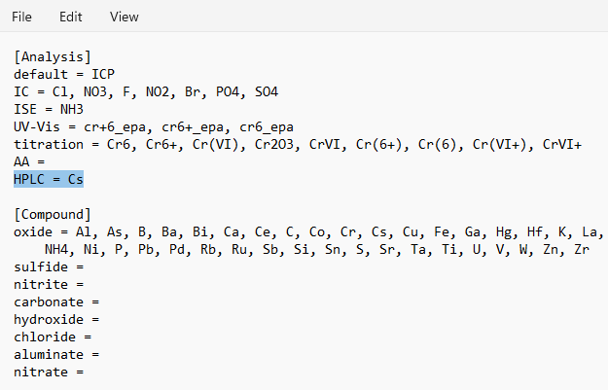
Figure 11: Cs HPLC analysis.
Figure 10: configuring HPLC analysis for Cs.

We can also control the chemical compound of an analyte for example instead of reporting Na oxide we can report Na sulfite by creating a sulfite list in the configuration file and adding Na.
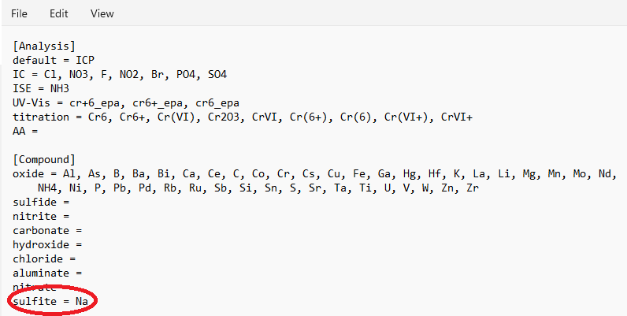
Figure 12: Creating a new metal compound for analysis.
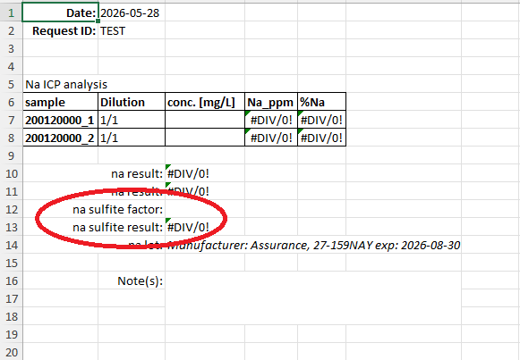
Figure 13: New Na sulfite factor and result.
Location of the saved master_woorkbook.xlsx is controlled by attaching a URL to destination in the Path section of the configuration file. If a path is not provided it defaults to directory that the program is running.

